Parallel extraction of summary information across multi-element arrays
(Agenda)
Experiment 1 (S-VSs)

Variables
experiment.task = 'shape';
variables.setsizes = [2,4,8];
variables.timings = .2;
variables.variances = [.1 .2];
variables.means = 0:.05:.2;
variables.counters = 1:25;

Experiment
19th November, 2012 - 10 subjects

ANOVA performance
Significant effect for mean (p<0.000).
Significant effect for variance (p<0.022).

ANOVA response
No effects.

ANOVA reaction times
No effects.

Response plots
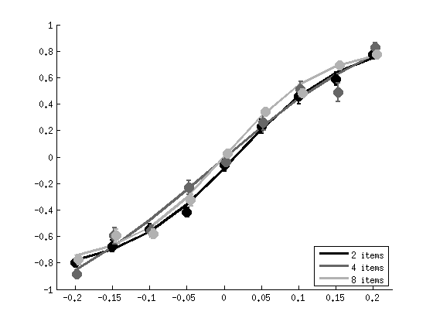
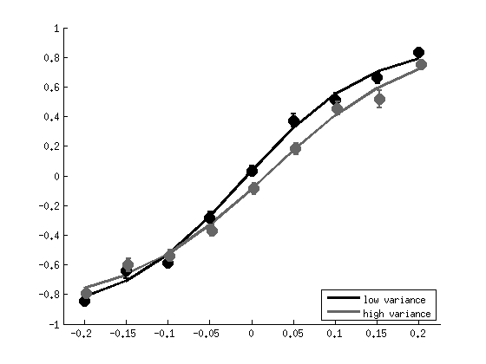

Experiment 2 (B-VSs)

Variables
experiment.task = 'both';
variables.setsizes = [2,4,8];
variables.timings = .2;
variables.variances = [.1 .2];
variables.means = 0:.05:.2;
variables.counters = 1:25;

Experiment
26th November, 2012 - 16 subjects

ANOVA performance
Significant effect for mean (p<0.000).
Significant effect for setsize (p<0.001).
Non-significant interaction between mean and variance (p<0.059).

ANOVA response
No effects.

ANOVA reaction times
No effects.

Response plots
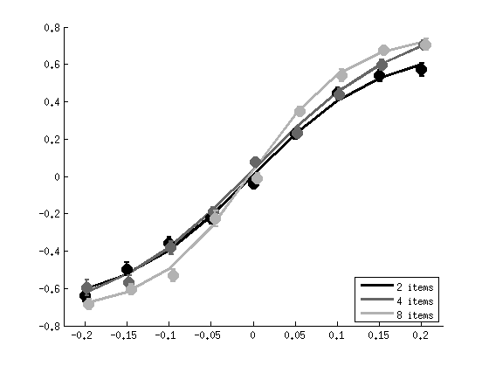
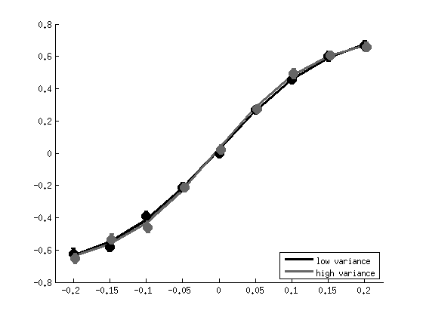

Experiment 3 (S-TSs)

Variables
experiment.task = 'shape';
variables.setsizes = [1,3,6,12];
variables.timings = [.1,.2,.4,.8];
variables.variances = .15;
variables.means = -.2:.05:.2;
variables.counters = 1:15;

Experiment
21th January, 2013 - 10 subjects

ANOVA performance
Significant effect for mean (p<0.000).
Significant effect for setsize (p<0.019) – though only for setsize 1?
Significant effect for timing (p<0.007).

ANOVA |error|
Significant effect for mean (p<0.000).
Significant effect for setsize (p<0.000) – though only for setsize 1?
Significant interaction between mean and setsize (p<0.000).
Significant effect for timing (p<0.010).

ANOVA response
Significant effect for mean (p<0.000).
Non-significant interaction between mean and setsize (p<0.061).
Non-significant interaction between mean and timing (p<0.025).

ANOVA reaction times
Non-significant effect for timing (p<0.057).

Response plots
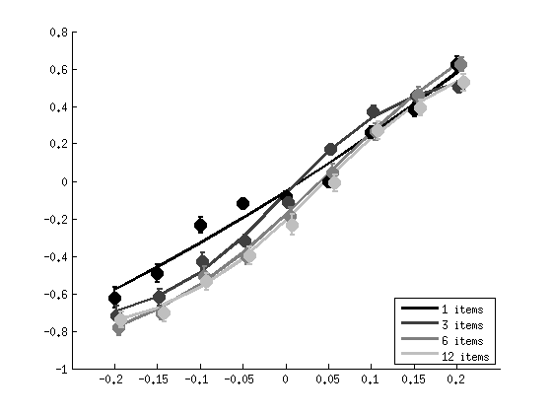
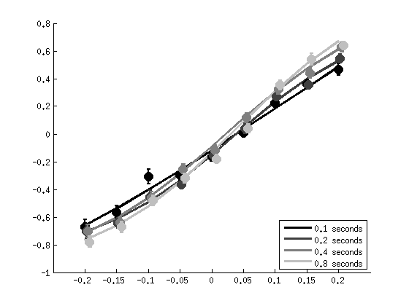

Experiment 4 (S-spectrumTSs)

Variables
experiment.task = 'shape';
experiment.spectrum = 1;
variables.setsizes = [1,3,6,12];
variables.timings = [.05,.1,.2,.4];
variables.variances = .15;
variables.means = -.2:.05:.2;
variables.counters = 1:15;

Experiment
13th February, 2013 - 5 subjects

ANOVA performance
No effects.

ANOVA |error|
Non-significant effect for setsize (p<0.062).

ANOVA response
Significant effect for mean (p<0.012).
Non-significant effect for setsize (p<0.065).

ANOVA reaction times
No effects.

Response plots
